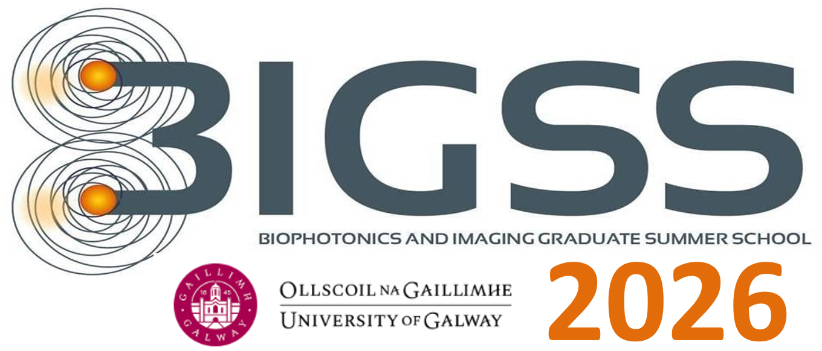

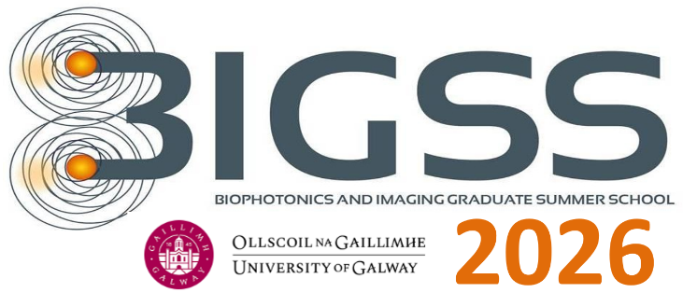
August 3rd - August 7th 2026, GALWAY, IRELAND
Course corresponds to 5 ECTS credit

Chair
Prof. Martin J. Leahy

Organising Committee
Éanna Johnston, Conor Byrne, Rajib Dey, Mahendra Kusuma Nugraha, Sergey Alexandrov

DAY 0

Sunday, August 2nd
Arrival and check-in of students and professors at the Galway, Dunlin accommodation.
https://stay.universityofgalway.ie/
Address : Upper Newcastle, Galway, H91 DFD0
Phone : +35391 527 112

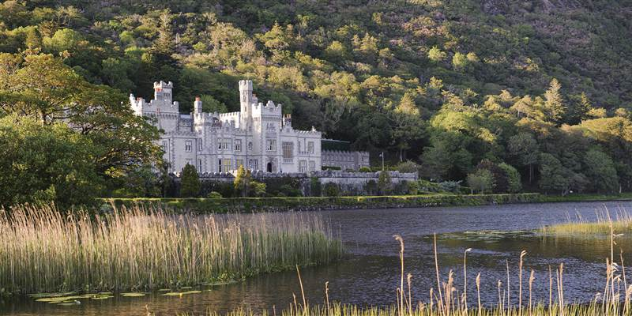

DAY 1

Monday, August 3rd
08:00 Bus to Diamond Hill
Breakfast on the bus
Hike on National Park trail ~ difficulty level 4 (easier than Croagh Patrick. Easier
alternatives are also available. *Subject to change due to weather, etc.
12:30 pm Lunch in Veldons
14:00 pm Check into Kylemore
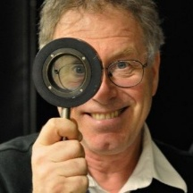 Steve Jacques, University of Washington, Seattle
“Tissue Optics and Laser-Tissue Interactions”
Origins of optical properties; Measurements of optical properties - lookup tables; Monte Carlo simulations; Coupling tissue optics into modelling of photochemical, photothermal and photomechanical effects.
14:30-15:30 | Part I
15:30-16:30 | Part II
16:30-17:00 | Coffee break
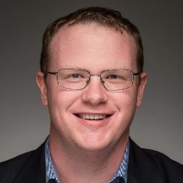 Thomas O’Sullivan, University of Notre Dame
17:00-18:00 | Part I
18:00-19:00 | Part II
19:00-21:00 | Dinner

DAY 2

Tuesday, August 4th
08:15-09:00 Breakfast
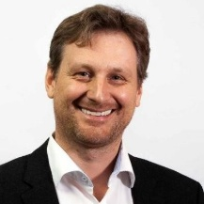 Rainer A. Leitgeb, Medical University of Vienna
09:00-10:00 | Part I
10:00-11:00 | Part II
11:00-11:30 | Coffee break
11:30-12:30 | Part III
12:30-13:30 | Lunch
13:30-15:30 | Poster Session
“Optical Coherence Tomography”
Fundamentals of OCT and angiography; Translational Optical Imaging in Medicine; Image and Signal Processing
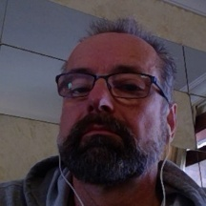 Lothar Lilge, University of Toronto
15:30-16:30 | Part I
16:30-17:00 | Coffee break
17:00-18:00 | Part II
18:00-19:00 | Part III
19:00-21:00 | Dinner

“Photo Medicine, Radiation Medicine and Nano Medicine”
Physical energies in the form of photons can interrogate or modify the chemical composition of tissue thus providing clinical information of or destroy it. This lecture, covering mostly therapeutic applications will juxtapose ionizing and optical radiation by their interaction methods with matter and in particular biological tissues. The pathways from physical energy deposition to biological and clinical effects are discussed, both as a function of quantum energy and power density. The abilities of photons with different quantum I energies to transverse tissues and ultimately destroy or modify it, is reflected in their respective approaches for personalized treatment planning. Methods and means to augment energy deposition in particular via the use of nano particles will be presented. Clinical examples of the various photon mediated treatment modalities will be used to highlight the medical opportunities ionizing and optical radiation harbour.

DAY 3

Wednesday, August 5th
08:15-09:00 Breakfast
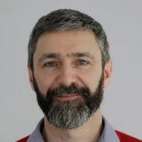 Ben Cox, University College London
“Photoacoustic Tomography – Microscopy”
A historical perspective; Basic principles of photoacoustic signal generation, Imaging instrumentation: microscopy and tomography; Basic principles of image formation and processing; Multi-modal combinations; Biological and translational applications.
09:00-10:00 | Part I
10:00-11:00 | Part II
11:00-11:30 | Coffee break
11:30-12:30 | Part III
12:30-13:30 | Lunch
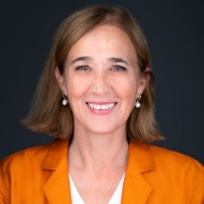 Jessica Ramella-Roman, Florida International University
“Polarization Microscopy”
Optical polarization-sensitive techniques for applications in medical imaging and the diagnosis of various pathologies, with a particular interest in women’s health.
13:30-14:30 | Part I
14:30-15:30 | Part II
16:30-16:00 | Coffee break
16:00-17:00 | Part III
DAY 4

Thursday, August 6th
08:15-09:00 Breakfast
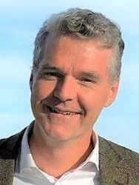 Brian Pogue, Dartmouth University, USA

“Optics in Surgery & Radiation Therapy - Photochemistry/Radiochemistry”
Surgical devices, Variations of devices, Optical tracers, Molecular optical tracers, Photochemistry & photodynamic therapy, Radiation therapy, Radiochemistry, Nanoparticles in photophysics and radiophysics, Optical Diagnostics in radiation therapy.
09:00-10:00 | Part I
10:00-11:00 | Part II
11:00-11:30 | Coffee break
11:30-12:30 | Part III
12:30-13:30 | Lunch
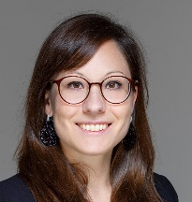 Jana Kainerstorfer, Carnegie Mellon University, USA
14:15-15:15 | Part I
15:15-15:45 | Coffee break
15:45-16:45 | Part II
16:45-17:45 | Part III

“Diffuse Optical Spectroscopy in Deep Tissue and the Brain”
Diffuse optical tomography; diffuse correlation and speckle contrast spectroscopies; neurocritical care; critical care; neurodevelopment; diffuse optical spectroscopy and tomography; near-infrared spectroscopy.
Evening Activity - Dinner & Trip to Traditional Irish Music Pub - Galway City
DAY 5

Friday, August 7th
08:15-09:00 Breakfast
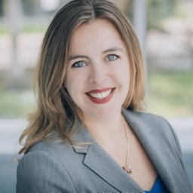 Caroline Boudoux, University of Montreal, Canada

“Endoscopy”
Instrumentation for in vivo imaging. Fibre types (single-mode, multimode, double-clad, photonic crystals and fiber bundles), couplers, scanners, and detection schemes. Challenges associated with handheld, laparoscopic and endoscopic applications of spectroscopy, OCT, confocal, Raman and nonlinear microscopy.
09:00-10:00 | Part I
10:00-11:00 | Part II
11:00-11:30 | Coffee break
11:30-12:30 | Part III
12:30-13:30 | Lunch
14:00-19:00 | Hands on Training Sessions
19:30-Late | Graduation Ceremony and Farewell Dinner in the Aula Maxima, University of Galway
Presentation of student certificates.

d

