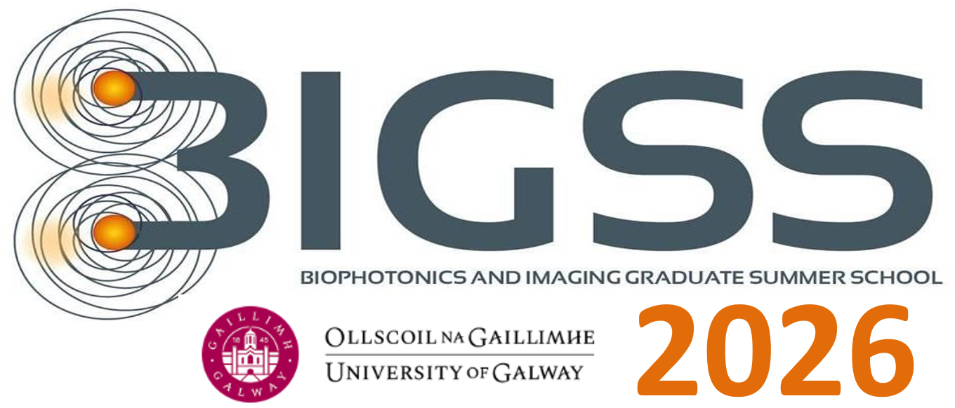

August 3rd - August 7th 2026, GALWAY, IRELAND
Course corresponds to 5 ECTS credit

Chair
Prof. Martin J. Leahy

Organising Committee
Éanna Johnston, Conor Byrne, Rajib Dey, Mahendra Kusuma Nugraha, Sergey Alexandrov

DAY 0

Sunday August 2nd

Arrival of students and professors to Dublin or Shannon.

Activities:

18:00 -18:30: Bus Transfer to Kylemore Abbey, Pollacappul, Co. Galway
Registration
Accommodation Check in at Kylemore Abbey
Dinner for everybody in Kylemore

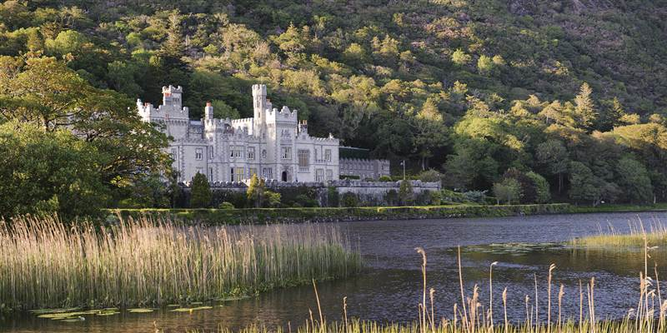

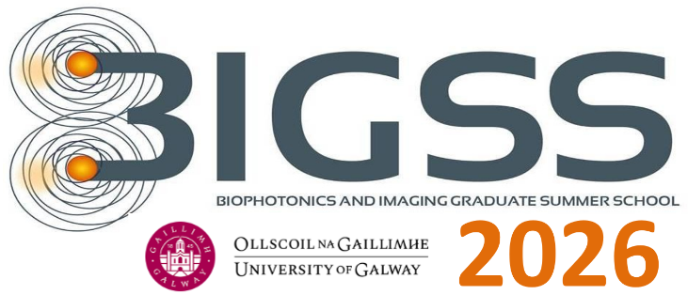
DAY 1

Monday August 3rd
Bus leaves Clifden 08.15
Kylemore breakfast 08.15

08:15-09:00 Breakfast

Thomas O’Sullivan and Steve Jacques, University of Notre Dame

‘Tissue Optics and Laser Tissue Interactions’

09:00-10:00 Part I

10:00-11:00 Part II

11:00-11:30 Coffee break

11:30-12:30 Part III

12:30-13:30 Lunch

Rainer Leitgeb, Medical University of Vienna

‘Optical Coherence Tomography’

13:30-14:30 Part I

14:30-15:30 Part II

15:30-16:00 Coffee break

16:00-17:00 Part III

18:00-21:00 Activity – Trip around Kylemore Abbey (indoor) and dinner

DAY 2

Tuesday August 4th
08:15-09:00 Breakfast

Lothar Lilge, Toronto

‘Photo Medicine, Radiation Medicine and Nano Medicine’

09:00-10:00 Part I

10:00-11:00 Part II

11:00-11:30 Coffee break

11:30-12:30 Part III

12:30-13:30 Lunch

13:30 – 15:30 POSTER SESSION

Hike on National Park trail ~ difficulty level 4 (easier than Croagh Patrick. Easier Alternatives also available). * Subject to change due to weather etc.

Evening Activity – Trip to Clifden & Meal

DAY 3

Wednesday August 5th

08:15-09:00 Breakfast
Ben Cox, University College London
‘Photoacoustics’

09:00-10:00 Part I

10:00-11:00 Part II

11:00-11:30 Coffee break

11:30-12:30 Part III

12:30 - 13:30 Lunch

Jessica Ramella-Roman, Florida

‘Polarization’

13:30-14:30 Part I

14:30-15:30 Part II

16:30-16:00 Coffee break

16:00-17:00 Part III

Brian Pogue, Dartmouth University, USA

‘Optics in Surgery & Radiation Therapy - photochemistry/radiochemistry’
18:00 – 19:00 Part I

19:00 – 20:00 Part II

20:00 – 21:00 Part III

DAY 4

Thursday August 6th

08:15-09:00 Breakfast

Jana Kainerstorfer, Carnegie Melon, USA

Diffuse Optics

09:00 – 10:00 Part I

10:00 – 11:00 Part II

11-00 – 11:15 Coffee Break

11:15 – 12:15 Part III

12:30- 14:00 Lunch on bus

14:15 – 19:00 – Hands on Imaging Training Sessions

15:30-16:00 Coffee break

Evening Activity - Dinner & Trip to Traditional Irish Music Pub - Galway City

DAY 5

Friday August 7th

Caroline Boudoux, University of Montreal, Canada

‘Endoscopy’
08:15-09:00 Breakfast
09:00-10:00 Part I

10:00-11:00 Part II

11:00-11:30 Coffee break

11:30-12:30 Part III

12:30-13:30 Lunch

14:00 – 19:00 – Hands on Training Sessions

19:30 – Late: Graduation Ceremony and Farewell Dinner in the Aula Maxima, University of Galway
Presentation of student certificates

d

