Abstract Preparation Guidelines For BIGSS 2024 [Poster Title]
Author Name, Supervisor Name, Number of post graduate years completed

Institution, e.g.: NBIPI Tissue Optics and Microcirculation Imaging Facility, School of Natural Sciences, University of Galway, Galway, Ireland

Research Background: Please provide a summary of the background to your research area. For early stage researchers (First year, or early second year research candidates), it is sufficient to describe the scientific background of the potential research areas that you are have an interest in. The purpose of this section is to introduce your personal research topic (500 words max.).

Aims: State briefly the primary aim(s) of your research (50 words max.).

Methods: Description of the experimental methods used during the course of your research to achieve these aims.

Results & Conclusions: Please discuss any preliminary results or key findings to date. For very early stage researchers who may not have results of their own just yet, you are encouraged to summarize any key findings to date that will directly relate to the work you plan on undertaking. For example, recent work that has been carried out within your research group that you may have been involved in, or that you will be following on from.

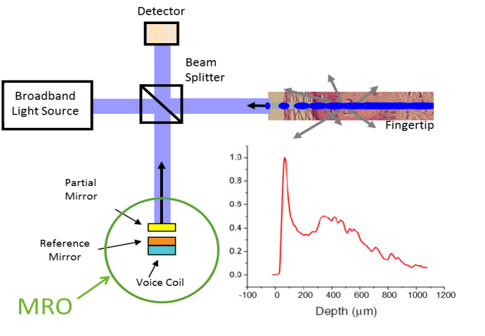
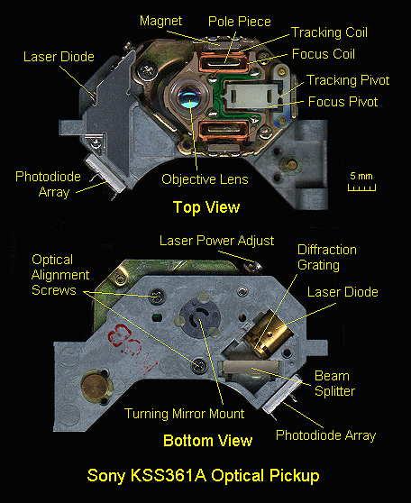
The abstract should not exceed one page in length. The dimension of the paper is A4 size paper: 210 mm x 297 mm. Margins should be 2.5 cm on all sides, and the text should be written in 11 point Times New Roman (and Symbol, if necessary). A couple of Figures/Tables may be included to the abstract. Figures should be centred and small ones may be placed side by side as shown in Figure 1, and must be located completely inside the paper margins. Captions, in 9 pt, should be positioned in centre below the figure with table captions above the tables.
Fig. 1. A typical CD-ROM pickup unit. | Fig. 2. Multiple reference time domain OCT (MR-OCT) system using a partial mirror.
All references should numbered and appear at the end of the abstract in the same order as used in the text. References should be aligned to the left. In the main body of the text, the reference designation should be with square brackets [1], and several references can be included together using a comma [2, 3] or a dash [1-3]. The abstract must be submitted in a PDF format.

References:

[1] A. Author and B. Author, Title of paper, Journal Name, vol., pp. startpage-endpage, (year).
[2] A. Author, B. Author, C. Author, Title of paper, Journal Name, vol., pp. start-end, (year).
[3] A. Author, Title of book (Publisher), Chapter, (year).

